Algebra I CP Syllabus

2018-2019 Academic School Year

Instructor: Mr. Rojas (Mathematics Department)
Location: Room 1107
Phone: 720-4502 ask to be connected to room 1107
Email: jrojas@djuhsd.org
Text: McDougal Littell Algebra 1: Concepts & Skills

Prerequisites:
Pre-Algebra

Course Outline:
The following concepts will be covered by all CCHS math teachers.

1st Semester Topics | 2nd Semester Topics
- Unit #1 Solving Linear equations, Inequalities, and  - Absolute Value equations | - Unit #5 Solving Systems of Linear Equations (Part 2)
- Unit #2 Graphing Linear equations and Inequalities and  - Absolute Value | - Unit #6 Exponent Properties and Exponential Functions
- Unit #3 Statistics (Part 1) | - Unit #7 Operations with Polynomials and Factoring
- Unit #4 Writing Linear Equations | Unit #8 Radicals
- Unit #5 Solving Systems of Linear Equations (Part 1) | Unit #9 Exploring Quadratic Functions
 | Unit #10 Statistics (Part 2)

Course Goal:
To learn the fundamentals of 8th grade Algebra, and apply these mathematical principles and concepts to real life problems (All ESLR’s)

Course Purpose:
Symbolic reasoning and calculations with symbols are central in algebra. Through the study of algebra, a student develops an understanding of the symbolic language of mathematics and the sciences. In addition, algebraic skills and concepts are developed and used in a wide variety of problem-solving situations. Students will acquire respect for the study of mathematics, acknowledge the importance of logical reasoning in our daily lives, and experience the relevancy of mathematics in the real world.

Material Needed:
- Text
- Spiral Notebook / 3-Ring Binder
- #2 Pencil & Scientific Calculator

Notebook Expectations
- Categorized dividers: Assignments, Labs, Notes, Handouts/Worksheets, Group Activities, Warm-Ups, Enrichments, etc…
- All notes, handouts, assignments & assessments should be kept in the binder and dated

Class Rules:
- Respect others and their property
- Keep your general area clean and orderly
- Come to class ready to learn and prepared to succeed
- Late means not in your seat when the bell rings
- Follow all teacher instructions

Student’s Behavioral Expectations:
- School board policies and classroom rules will be enforced. Non-compliance will result in disciplinary action. The consequences vary depending on frequency of violation. Consequences could include after school detention with teacher or lunch detention in room, parent contact, and/or a referral to the office. Any student who creates a severe disruption or dangerous situation will be referred to the principle’s office immediately. Please refer to the student handbook for school and classroom rules and discipline procedures.
- Class participation is expected
- Pertinent discussions are welcomed.

Student’s Academic Expectations:
- Assignments will be assigned on a regular basis and due the next day unless prior arrangements are made with the teacher. Some assignments will be directly extracted from the text and others from handouts. All assignments must be turned in by the specified deadline unless prior arrangements are made with the teacher.
- Students should request make up work from the teacher at the end of the period.
- If a student is absent the day of an assessment (test/quiz), the day the student’s return to class is typically used to make up the assessment.
- Students have multiple opportunities to demonstrate academic understanding, achievement, and mastery.
- Every student is expected to seek out help immediately when there is evidence of falling behind (After School Tutorial Program).

Grading Scale:

Weight Percentage | Assignments
30% | Assignments (Homework/Classwork)
10% | Quizzes (FACS A/B)
20% | Unit Test (FACS C Multiple Choice)
15% | Unit Test (Free Response)
5% | Midterms
20% | Final Exam

Instructor’s Pledge:
- Will create a well-managed environment for all students to succeed.
- Will provide motivating and interesting learning experience.
- Will provide a positive expectation for students’ success.
- Will design lessons for students’ mastery.
- Will exhibit positive expectations for all students.
- Will create a classroom climate that communicates a positive expectation.

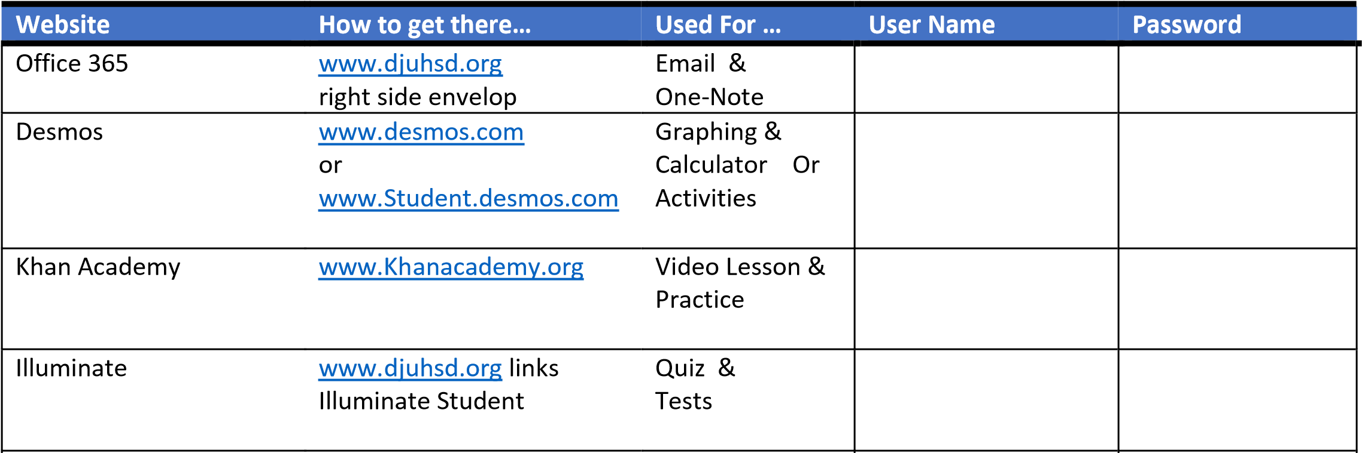
Student Credentials:

